Spring A-15 Cabinet Meeting Minutes
3:00 PM Sunday, June 14th, 2015
Hosted by Woolwich Community Lions at Lions Hall, 40 South St W, Elmira

- Call to order – 3:05 PM by DG Tim DeBlock
Attendance as indicated:
VOTING CABINET
IPDG Denis Vinette | DG Tim DeBlock | 1st VDG Diane Smith | 2nd VDG Wayne Litt
CS Dennis Lougheed | CT Peter Oswald | RC Charlene Teaasdale | ZC Jim Davis
ZC Debbie Cserhalmi | RCAjit Manku (R) | ZC Rae Rotchell | ZC Kevin Banfield
RC Rick Banks | ZC Jim Keron | ZC Tracey Leary
COMMITTEE CHAIR
Lion Linda Vinette | PDG Doug Smith | PCC Tim Cronin (R) | Lion Janet Dawson-Brock
Lion Bill Patterson (R) | PDG Thom Herrmann | Lion Maurie Payne | Lion Ernie Kaethler
PRC Paul Anstett | Lion Pat Mclean | Lion Adam McMurran | PDG Karen McNeight (R)
Lion Joanne McQuiggan (R) | PRC Robert Montgomery | PID Bruce Murray | PZC Mary Ann Ward (R)
Lion Penny Overboe(R) | PDDG George Patton | Lion John Pepper (R) | IPDG Norma Peterson
PDG Nancy Ransom | Lion Aline Chan | PID Art Woods | PDG OJ Wilura
PRC Vaughan Braby | Lion Lorea Boogerman | Lion Bob Rutter(R) | PCS Ted Rypma
PDG Larry Wainwright | PRC Rick Bell (R) | Lion Rudy Boogerman
In attendance also were approximately 50 other Lion Members
(R) – Regrets
- Moment of Silence, O Canada
- Welcome - DG Tim DeBlock
Welcome all to our final Cabinet meeting of the year. I would like to thank the Woolwich Community Lions for hosting and to all of you for attending. Along with the regular tasks of administrative work today’s meeting will give us time to maybe reflect on the past year but also marks the transition for next year’s committee chairs, Cabinet and our incoming Governor for this is the last time we will all gather in our current roles.
- Setting of Protocol – VDGE Charlene Teasdale
- Transfer of the Chair to DGE Diane Smith
Traditionally in A15 we transfer the chair of this meeting to our incoming Governor. Before I do this I thought it appropriate to present DGE Diane with something. Diane has put much energy and time into planning for next year. She has been remodeling some of our administrative structure, getting committee chairs, training, planning, scheduling, team building and sharing with the incoming Cabinet some of her hopes and dreams for our District; a lot of hard work indeed. And with hard work comes rewards. Diane recently shared with me how good she was feeling about the people she was surrounded by, the members of her incoming Cabinet, the people she had as Committee Chairs and the membership of our District and the Clubs; gifted capable people who will be able to do many good things in the spirit of Lionism. She likened it to an orchestra many people with many different gifts making beautiful music together. So every great orchestra has a great Director. DGE Diane, with this baton, I give you the chair of this meeting.

- Adoption of the Agenda
Cabinet elected to withdraw a motion, amending the Convention Policy, deferring action pending further study until the August cabinet meeting.
MOVED to adopt the agenda as amended. Carried.
- MOVED to Approve the Minutes of the March 21st & 22nd, 2015 Convention Cabinet Meeting. Carried.
- Secretary’s Report
MOVED to acknowledge receipt of the Secretary’s Report. Carried.
- Treasurer’s Report
  - Report and Financial Statements 2014-2015
MOVED to acknowledge receipt of the Treasurer’s Report and Financial Statements. Carried.
- Matters Arising
- New Business
  - Motion to Rescind A Convention Hosting Bid
On receipt of a letter of request from the Lions Club of Kitchener signed by President, PDG Mike Hilling and Committee Chair, PDG O.J. Wilura
MOVED that District Cabinet rescind the motion passed at the June 16, 2013 District Cabinet Meeting in Belwood to approve the bid of the Lions Club of Kitchener to host the 2017 District A-15 Convention. Carried.
  - Motion to Host the 2017 District Convention
MOVED that District Cabinet approve the joint bid of the Elmira Lions and the Woolwich Community Lions to host the 2017 District A-15 Convention. Carried.
See Pages 17 - 21
  - Motion to Consolidate District A-15 Policy
WHEREAS the policies of District A-15 are currently scattered across several current documents, and
WHEREAS the current policies contain redundancies as well as obsolete policy statements
MOVED to replace all current District A-15 Policy documents with a single replacement document titled District A-15 Policy Manual. Carried.
- Motion of Direction to MDA Council
WHEREAS the St Mary’s Lions Club has passed a motion asking that the District A-15 Cabinet request that the MDA Council of Governors revitalize the committee addressing changes in the MDA convention or form a new committee to do the same,
MOVED that the District A-15 cabinet forward the following to the MDA Council of Governors;
WHEREAS attendance at the recent MDA convention, the number of votes cast and expression by many Lions that they can no longer afford the cost of the convention as currently structured suggests the need for change,
MOVED that the MDA Council of Governors revitalize the committee addressing changes in the MDA convention or form a new committee to do the same and report within two years of passage of this motion.
MOVED to amend the motion to read “within one year” rather than “within two years”. Amendment Carried
Amended motion Carried.
- Cabinet Reports - See Pages 9 - 10
MOVED to acknowledge receipt of the Cabinet Reports. Carried.
- Committee Reports - See Pages 11 - 16
MOVED to acknowledge receipt of the Committee Reports. Carried.
- District Governor’s Remarks
I started to sit down and try and put together a list of people, and words to thank the many Lions, and friends who have contributed to the journey our District has been on this year. Couldn’t do it. I tried to think of something I could get for those who contributed so much in helping all of us make our communities a better place to live and enabling us to help those less fortunate. Couldn’t think of it. You see I believe all of us in our own way, with our own story contribute to what we are able to do. We have heard for many years that A15 is a great District. I believe we are, not because of numbers or data but because of the people. All of the members and all of the people we reach out to, are part of our story and that is what makes us unique and special. So it’s difficult to acknowledge any one part more than another for without all the pieces our story would not be complete.
So this is what I came up with. Thank-you you to the Lions of A15, the members and the Clubs for all you have done and continue to do to help those in need. Thank-you to everyone involved in District Committees and the work you did promoting and implementing our various programs and administrative bodies.
And to our Cabinet. I feel very fortunate to have been part of this team. All of you contributing in some way through your particular roles. To our Governors team, Denis, Diane & Wayne., not only are you making a huge impact on what we are doing as Lions but you were a huge support for myself and have become good friends.
Sometimes doing the work of being a Lion we end up far removed from our actual goal of serving our communities and helping those less fortunate. Whether at the Club Executive level, doing committee work in the District or being part of Cabinet it happens. Administrative work, training, dealing with many different personalities, balancing schedules, budgeting, all important work and a big job. And it is important to remember that as we do this work, our efforts filter through and enables us to help others.
With that in mind, and acknowledging that your Cabinet, these people that commit so much time and share their many gifts, are the administrative representative body of the members and that their work is about enabling us to reach out to others. To the District Cabinet of A15 2014-2015, on behalf of the membership of A15 and myself I would like to present to you a Lions Quest fellowship to say thank-you and to represent that your work truly impacts all of our service. You are all Lions Quest Fellows! Congratulations!
Finally, to any of you who have shared any part of your story with me, which realistically is all of you and sometimes maybe more of your story than I was actually hoping to hear. Whether in a brief conversation or through myself having had the good fortune of working together with you in service, you all have made an impact on my journey! Thank-you.
- DG Appreciation Plaque & Pin - DGE Diane Smith
On behalf of the District, I wish to extend our thanks to Lion Tim DeBlock. He has provided us with very capable leadership, and he has provided us all with the finest of examples of what it means to be a Lion.
Tim, I have been impressed with your gentle ways and your gift. for always finding the best in people. I personally thank you for your mentorship and your guidance through those sometimes choppy waters.
You are wished the very best in all that you do going forward. We will all benefit from your continued contributions to Lionism, your unwavering support and best of all, your ever-ready smile.
We give you our heart-felt thanks.
- DGE Gavel – DG Tim DeBlock
- DGE Diane Smith’s Remarks
To begin, I wish to thank the Lions ofA15 for giving me the opportunity to work with you and for you as District Governor. I appreciate your trust and support. I hope to continue to build on the foundation of what has gone before, based on values of teamwork and respect.
Our incoming International President, Dr. Jitsuhiro Yamada has set as his theme DIGNITY, HARMONY, HUMANITY, a goal, we will learn about much more as we go through our Lions year and one which we can exercise not only in our Lions lives but in our personal lives as well.
My own goal for the District this year is HOPE THROUGH SERVICE, with an emphasis on literacy projects both loca1 and global.
Our District is strong but there is always need for growth and advancement. Working together we can and will continue to do great things. I look forward to the year ahead. I welcome your input and I encourage open and honest communication at all levels.
In conclusion, I wish to offer a special thank you to the members of my club, Woolwich Community and to the members of the Lions Club of Elmira. You have encouraged me along the way, you have taught me many things, and you have made me fully understand the value of true friends.
DGE Diane introduced the 2015/16 District Cabinet.
- Toast, Lions Grace and Dinner
- Adjournment – 4:35 PM
SECRETARY’S REPORT TO CABINET

Between April 7th and April 24th, 2015, members of the District A-15 Voting Cabinet were asked via the District Cabinet Forum to review the final report regarding The Lions Resource Centre, Standard Grant GA 13852/A-15 in the amount of $60,000 US. Of the 15 members, 12 approved the final report, 2 did not respond within the requested time frame and the report’s author abstained. This two-thirds majority support of the final report allowed for its submission to International.

An A15 Cabinet Committee Resource Document has been created and made available to the Governor’s Team and all sitting and potential Committee Chairs. It may be found in the District Admin /District Publications Section of the District Web site at;

http://a15lions.org/pages/uploads/Directory/A15CabinetCommitteesApril2015.pdf

It is hoped that reference to the document will assist all in understanding the expectations and responsibilities associated with the positions they have been asked to take on. This is a living document and will undergo revision at least annually.

Club, Cabinet, Committee Chair and PDG directory preparation data verification files have been sent to all concerned along with instructions on how to proceed. You are reminded that data becomes unalterable after July 1st.

TREASURER’S REPORT TO CABINET

The financial records have been balanced and reconciled to the bank online statements as at May 31, 2015. The financial statements presented here fairly reflect the financial position of the District.

ADMINISTRATION ACCOUNTS
- All Clubs have paid District dues.
- Expenses are up to date for invoices received in May – there are year-end invoices for the Leadership Seminar, GLT/GMT mileage etc that are to be reviewed and paid in June but not included in the Financial statements.
- I am confident we will end the year with a surplus and will address options after the June 30 statement is available to present at the August cabinet meeting..

TRUST ACCOUNTS
- The balance sheet for the Trust accounts is an accurate reflection of all balances held in Trust and all accounts have been reconciled to the Bank online records as at May 31, 2015.
- There are a number of Lions projects with funds held that will be sent to the respective program / Camp in June.

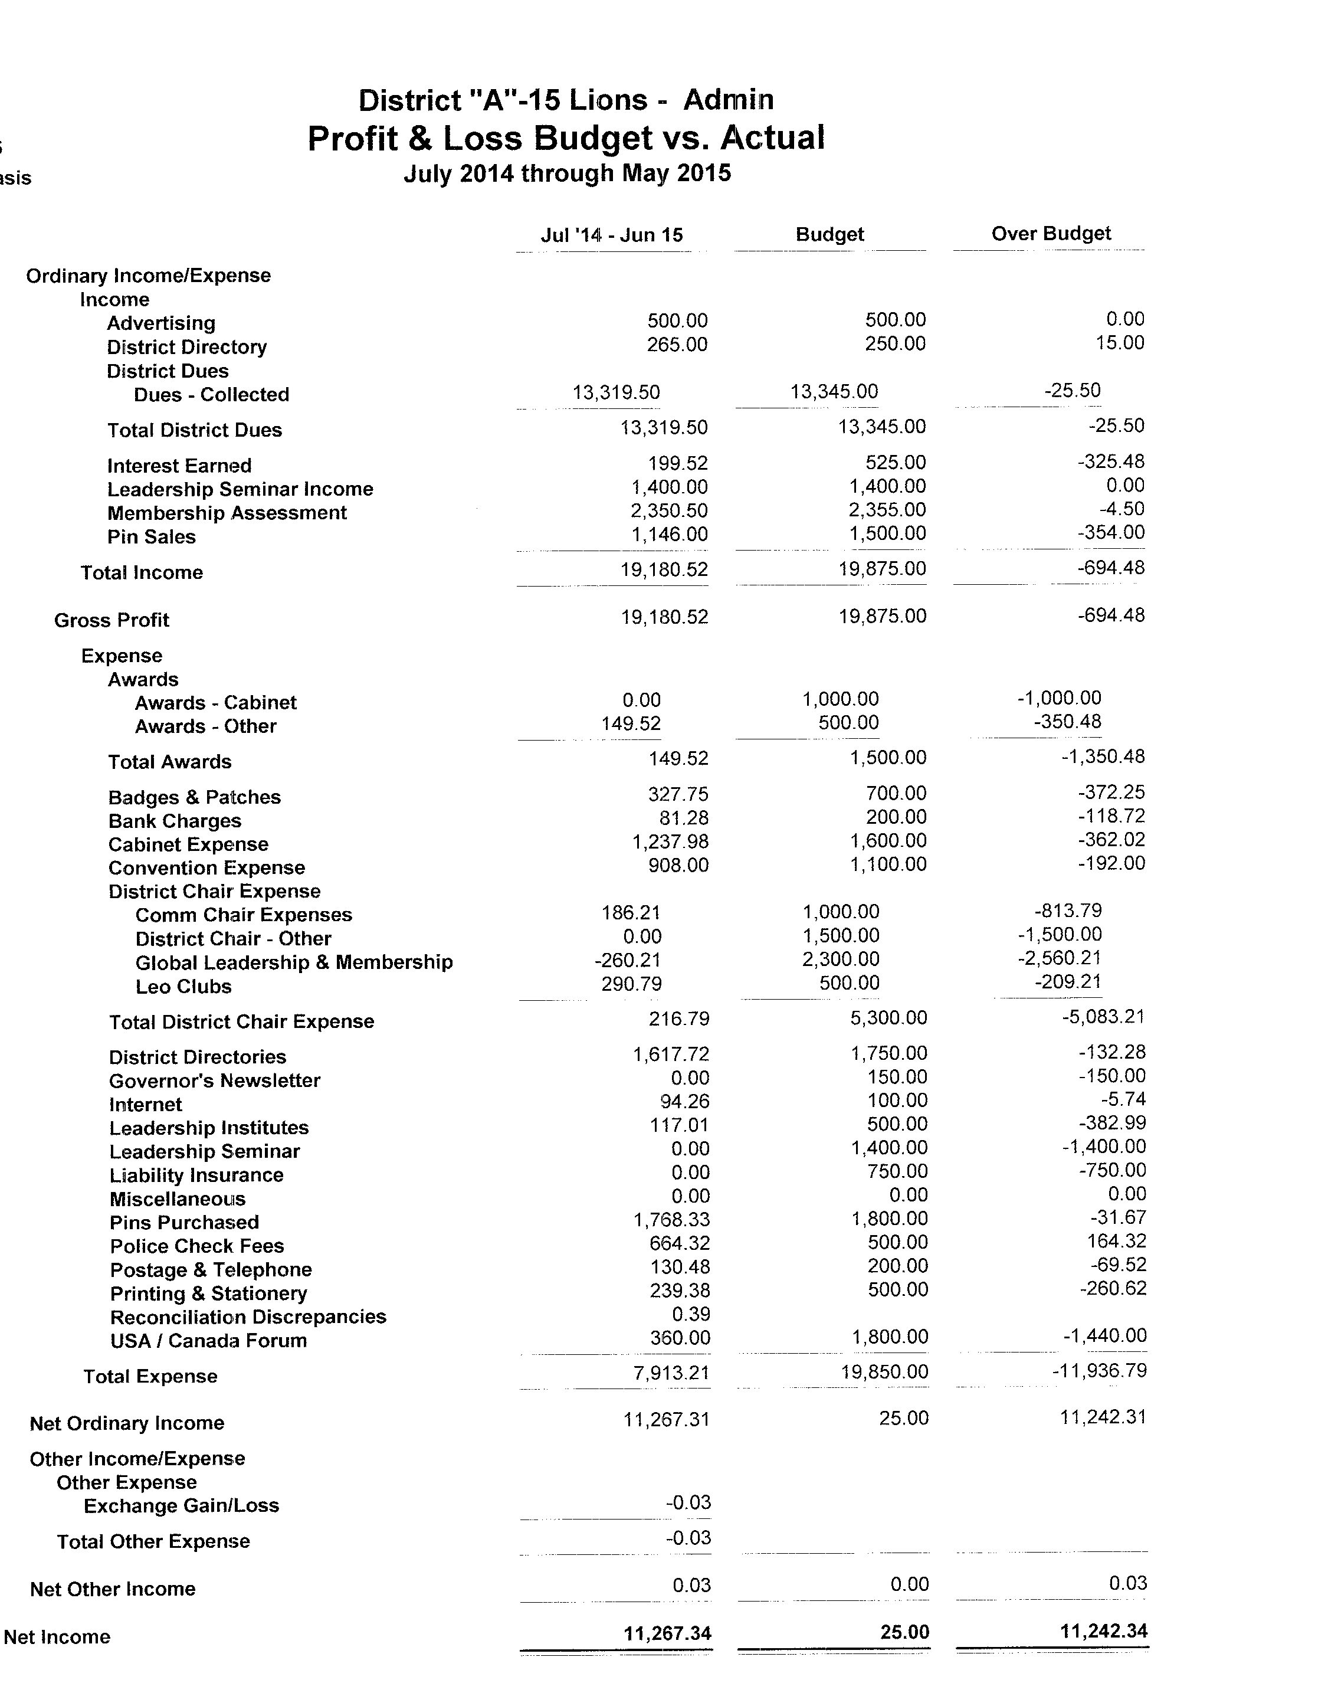
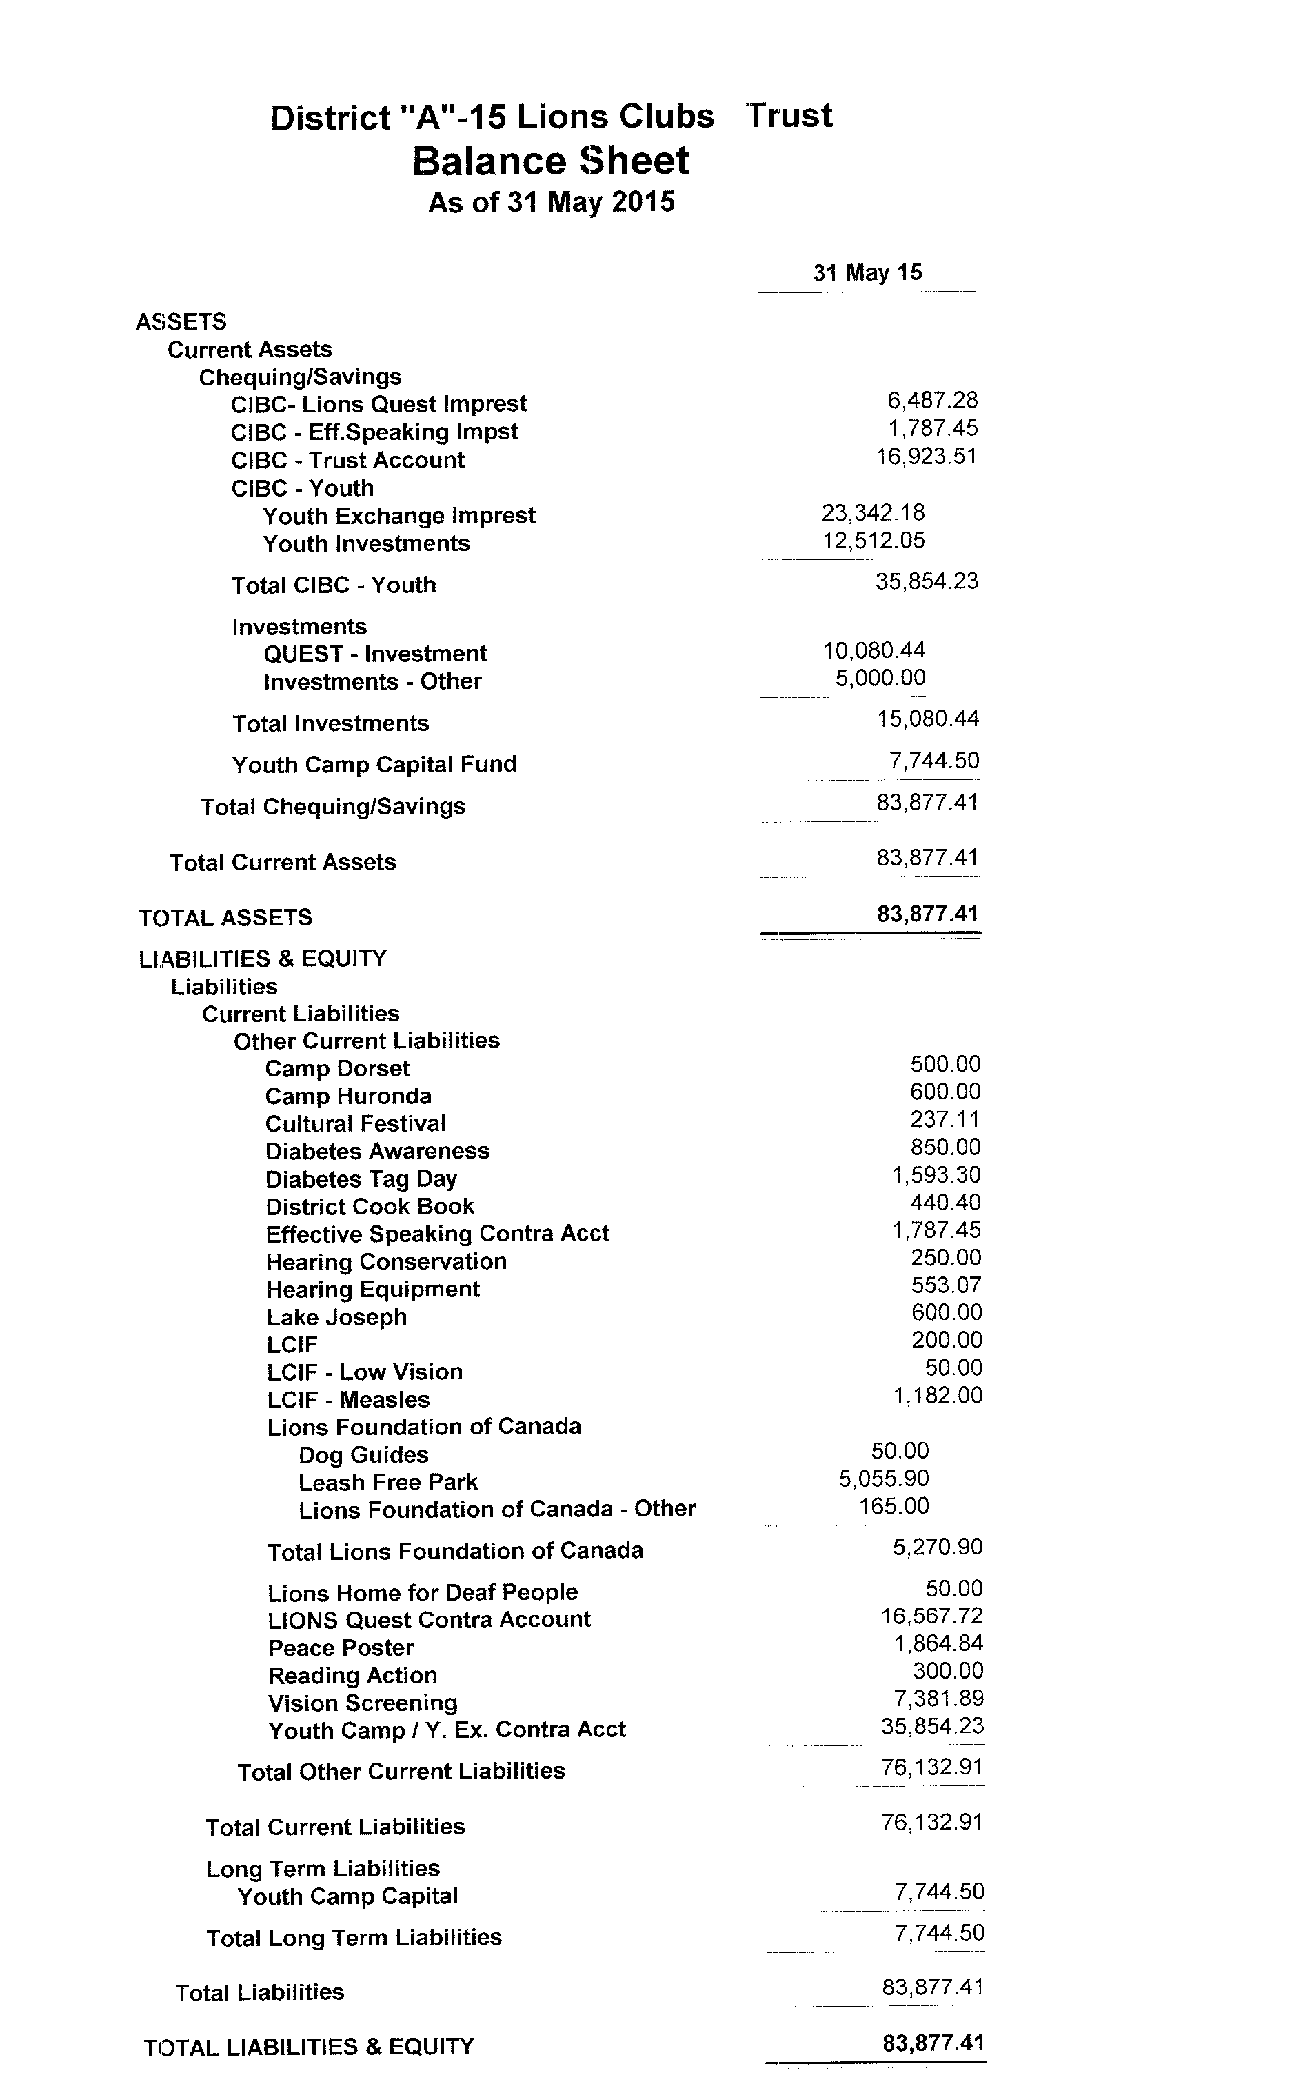/;.

CABINET REPORTS
1St VDG –Diane Smith
Since the Cabinet meeting held at the District Convention in Stratford in March, an interactive training session for the incoming Cabinet members was held in St. Jacobs. In the coming Lions year, there will be an emphasis at the Zone Chair visits and at the zone meetings on the sharing of ideas to make our clubs run smoothly. We want to hear from you, the members, what is working well and what is not.
On April 16th another successful Lions Now session was held. This event allowed for a number of committees within the District to showcase new developments and to provide information for members to take back to their clubs.
From May 21st -24th the annual convention for MD “A”, was held in Kingston. Lions events, such as this, provide an opportunity to meet Lions from other Districts, to socialize and to learn about different Lions resources and methods for handling challenges. Attending events beyond our own District can provide us with a fresh perspective.
I have enjoyed this year, getting to know the members of our District a little better and working with Cabinet under the capable direction of District Governor Tim.

2nd VDG – Wayne Litt
No Submission

IPDG – Denis Vinette
As this year comes to a close, so does my term on Cabinet. It has been an honour to work with the various leaders within our district and I can’t say enough about the sincerity and drive that each person has shown in their roles through the past 6 years. It has been “slice!”
Going forward, as a PDG, I will continue to offer my service where possible and to help ensure that District A15 remains the “best District in all of Lions”!

RC 9 - Ajit Manku
No Report

ZC 9E – Kevin Banfield
My son Rory and I had a great time at the Paris Maple Syrup festival. He really enjoyed the train ride the Paris Lions had running. From an outsider point of view, it sure seemed to be a successful day for Paris. It was also nice to see so many Lions from A-2 coming out to support and observe the Paris Lions Club in action. Lions Now – Wow what a great speaker with having David Phillips (climatologist) in. He made talking about our climate very interesting and explained why we are experiencing such extreme weather today. For me he really drove home the point as to why we need LCIF and how we as Lions help around the world when major climate issues occur. One other thing I took away from the evening was to, stop on a daily bases, look up in the sky, observe what is happening in the sky. At the Lions Leadership Club leadership event, we had a great turn out. I really enjoyed our guest speaker there as well. He confirmed a lot of things I have been thinking about when it comes to marketing Lions.

ZC 9S – Rae Rotchell
No Submission

RC37 – Rick Banks
I am pleased to report that all Zone visits have long since been completed for Region 37. ZC37S Jim Keron has stepped forward as Region Chair for 37 and ZC Tracey has agreed to stay on as ZC for 37W. Lion Ian MacFarlane has agreed to be ZC for 37S which gives Region 37 a full slate of officers on District Council for the next Lion's year. Both Zone Chairs have generated some great enthusiasm this year and have responded very well to any requests for service and assistance.
Since my last report in February I have attended Cabinet, been involved with a great group of singers on the Saturday of the Convention and visited Zurich to welcome some new prospective members. I was pleased to be able to visit with two Lions members and hopefully helped them with some information and assistance on the computer/technical aspects of Lionism. Helping Secretary Dennis at the Officers Training was very interesting and worthwhile. I have enjoyed my time as Region Chair. I know that it was unusual for me to be involved in Region 37 when my home club is in Region 51 and I was very pleased that we have Lion Jim stepping forward for 2015/2016. My thanks to my Zone Chairs for doing such a great job and to the rest of our Cabinet members for all of the work they do to keep the District glued together. i look forward to the Zone Chair position for next year.

ZC 37S –Jim Keron
No Submission

ZC 37W – Tracey Leary
I would just like to say that I have really enjoyed my first year as Zone Chair!! I’m looking forward to doing it again next year. I’ve also had the privilege of inducting 4 new members on May 27th, 2015, into the Exeter Lions Club. The 3 members from Stratford and myself had a very fun filled evening. Thanks again to all of Zone 37W for a great year. Let’s keep up the great work and communication, for the Good of Lionism!!!

RC 51 – Charlene Teasdale
It’s hard to believe we are almost at the end of our Lions year. After a great Convention our Zone Chairs and Clubs here in 51 have been very busy. I have attended the Cabinet Officer training and have had the privilege of visiting the Elora Lions Club. I thoroughly enjoyed attending the Fergus Lions Club Grand Chef challenge. We had a gorgeous day for our Camp clean up at Five Oaks getting ready for our International Youth, there are still 2 young men who are looking for a host family, why not make this a Club project? It has been very rewarding to hear of new member inductions & that all Clubs have reported their incoming executive. Increasing membership seems to be a challenge that many Clubs are facing, but I believe if we work together and create a plan, we can all realize a growth in numbers. I am here to help in any way I can. Keep up the good work Lions.

ZC 51E – Jim Davis
No Submission

ZC 51W – Debbie Cserhalmi
It has been a busy year in Zone 51W. From building trails to building hockey rinks, to eye screening the Lions of 51W have been committing to our communities’ betterment. At the District level, many of our members engaged in sprucing up our various camps as well as the Memorial Forest at Breslau. At the International level, many clubs have donated funds to LCIF for ongoing and emergency needs to our larger Lions family.
It has been an honour and a pleasure to work with the Lions of 51W. In the run up to our Organization’s 100 Anniversary, I am sure the clubs in 51W will continue to live up to our motto, “We Serve”.
Have a great summer Lions!

COMMITTEE REPORTS

NOTHING TO REPORT AT THIS TIME OR NO SUBMISSION
Alert – Lion Adam McMurran, Constitution & By-Laws – PDDG George Patton, Cultural & Community Activities – RC Ajit Manku, Diabetes Awareness – PRC Rick Bell, District Bulletin & MDA Magazine Liaison – Lion Bob Rutter, District Historian – PDG Nancy Ransom, District International Relations – PID Art Woods, Elections & Credentials – PDG Doug Smith, GLT Liaison – VDG1 Tim DeBlock, GMT Club Success Team Leader - PRC Paul Anstett, GMT Membership & Club Growth Team Leader – PRC Vaughan Braby, GMT Membership Renewal – PDG Larry Wainwright, Hearing & Speech Action – Lion John Pepper, Information Technology – PCS Ted Rypma, LCIF –Lion Penny Overboe, LEO – PZC Marry Ann Ward, Lions Opportunities For Youth – VDG2 Wayne Litt, Lions Services For Children – Lion Joanne McQuiggan, Police Check Gatekeeper - PDDG George Patton, Protocol – PID Bruce Murray, Public Relations & Club Visits Liaison – PDG Norma Peterson, Sight Screening & Conservation – Lion Pat McLean, Yearbook Editor – PDG Karen McNeight

Camp Coordinator – PRC Rob Montgomery
Our Lions Camps are getting ready for another fabulous season and they would like to thank the clubs of A-15 for their support and donations. Please check their websites to view their wish lists as well.
I have been informed that there are metal roofs on most or all of the buildings at Lions Camp Dorset.
To view what is going on at CNIB Lake Joseph please click this link for the spring edition. http://www.cnib.ca/en/news/Pages/20150407_CNIB-In-Your-Community---Spring-Edition.aspx?
I have had the privilege of visiting five or six of our clubs and have left valuable information on our Camps. I am now in the process of booking for the new Lions year and look forward to the challenge ahead.
Please visit the websites of the various camps to find out what their wish list or needs are for the upcoming camp season.

GLT District Coordinator – IPDG Denis Vinette
Since my last report, I was involved in the leadership training for both our incoming Cabinet and for Club officers. The first of these, was held in St. Jacobs on April 11 with a second makeup session in Kitchener on April 29. Thanks go to the St. Jacobs Lions for letting use their den for this important training event.
I’m pleased to report that all members of the incoming Voting cabinet have attended at least one session. Discussions about teamwork and the roles and responsibilities of each position was presented as well as a message from our DGE Lion Diane Smith regarding her plans and vision for the coming year.
Next, the District Leadership Seminar was held on May 31 in Baden. As in previous years, the New Hamburg Lions Club provided the facility (at no charge I might add) and coordinated the morning coffee and muffins as well as the entire lunch program. Kudos to New Hamburg!
To begin the session, we had the opportunity to listen to Prof. Marvin Ryder from the De Groote School of Business, McMaster University speak candidly and honestly about the visibility of volunteerism and that of service organizations in Canada at this time. His thoughts regarding our position and relevance challenged us to think of where we want to be on the ladder of the service club list and in the general realm of the non-profit and charitable organizations. We followed that session with breakout sessions for President (and Vice Presidents), Secretaries, Treasurers and Membership Chairs and committees. Each of these was presented by a team of 2 individuals bring their own experience and knowledge to the table. Thank you goes out to all of the presenters for their great work.
Lastly, after a great and welcomed lunch, the club members had the opportunity to group with other clubs in their own Regions and discuss challenges, ideas and service that is relevant in their “neck of the woods”. This was something different this year and I hope to get some feedback from those who attended as to the value of holding what might be called a “Joint Zone Workshop” next year.
Lons are encouraged to explore the following wed sites for information on the Canada/USA Forum and the associated Lions University at http://www.lionsforum.org/ and http://www.lionsuniversity.org

Convention Host 2015 – Lion Maurie Payne
From March 20th to the 22nd, 2015 the Monkton Lions along with the help of a few other clubs hosted the 2014-2015, A15 Convention. Attendance was around 451, of that there was 397 Lions and Lioness, 13 Leo’s and 41 non-members.
For the luncheon we had an estimated 150 in attendance. The Banquet we had an estimated 161 in attendance. We had many positive comments about having the banners hanging in the hallway leading to the main Banquet Room.
The story telling around the campfire in the Wilderness of Service room was very well attended with most people finding it very entertaining. I have also sent along a financial report along with this committee report.

 |  | Monkton Lions Club
 |  | Profit and Loss
 |  | Convention March 2015
 | Expense
 |  | Gifts Int'l Guest | 90.62
 |  | Memorial Service, Flowers, Name Plates | 272.25
 |  | Entertainment | 600.00
 |  | Office Supplies - Toner, Labels | 330.57
 |  | Printing - Posters, Name Tags, Programs | 2061.94
 |  | Pins | 757.00
 |  | Arden Park | 31003.71
 | Total Expense |  | 35116.09
 | Income
 |  | Interest Income | 3.66
 |  | Raffle Draw | 1115.00
 |  | Advertising | 450.00
 |  | Banquet | 6798.00
 |  | Hospitality Room | 1500.00
 |  | Leo Registration | 130.00
 |  | Lion / Lioness Registration | 6749.00
 |  | Luncheon | 2368.00
 |  | Non Member Registration | 615.00
 |  | Pins | 1045.00
 |  | Room | 15352.32
 | Total Income |  | 36125.98
Net Income |  |  | 1009.89

Effective Speaking – Lion Ernie Kaethler
Right on Lions of A-15 for supplying the energy, teamwork, and necessary financial resources to make our District’s Effective Speaking program successful. Thank-you St George LC, for hosting our District finals, March 28th. 10 Clubs sent 44 contestants: Belwood(8); Breslau(3); Fergus(4) Guelph(7); Hickson(2); Sheffield(2); K-W Comm/Spirit(6); Camb/Highlands(2); St George(3); St Agatha(7). The venue, the hospitality, and the efficient judges, Lions volunteers, participants with families and friends made this a remarkable Opportunities for Youth event.
At the MD'A' finals in St Catharines, May 2nd, 36 contestants from 9 (of the 10) contributing Districts competed. Of District A-15’s six(6) entered contestants {all categories}, one(1) FIRST - Senior French, Avinash PANDEY, sponsored by Breslau LC; one(1) Second place - Junior French, Bruce HACKNER, Guelph LC; two(2) Third place - Intermediate French, Federico Chaux, Cambridge Highlands LC; & Senior English, Lori-Anne LITTLE, Fergus LC. All contestants were winners.
Our program's success is dependent in large part on the energies and financial contributions ... At the club level but it benefits from continued Zone, Regional and District encouragement and support. Of noteworthy mention is our District final sponsored by and held in St George (LC). The arranged facilities for 40 to 50 contestants, families, judges and volunteers was ideal; a real setting of a standard.
Next year's MDA Effective Speaking finals will likely be held in Ottawa (area), on the May 7th 2016 weekend, possibly sponsored by the Orleans LC. The 2016, A-15 District finals will be held on the last Saturday in March unless it is Easter weekend.

Environment – Lion Linda Vinette
The winning Photo at MD”A” convention in Kingston was Susan Bell from A16 and our photo for District A15 from Wayne Romphf in Thamesford came in third. Congratulations again Wayne for a wonderful photo.
The Breslau LFC facility cleanup on Wednesday, June 3rd 2015 went very well with the help of 36 wonderful Lions. Clubs participating this year, in alphabetic order, were Belwood, Breslau, Elmira, Elora, Kitchener, KW Community Spirit, Paradise, St. George, St. Jacobs and Woolwich. We also had a surprise volunteer visit from PDG Allen Snider and his lovely wife Lion Susan from St. Davids Lion Club in District A2. Very special thanks to the Elmira Lions Club for the great food and beverage. Of course we can’t accomplish this yearly project without the help of PID Art Woods as well as Lion Jason Crowe (Elmira Lion) and Chelsey who works as grounds keeper at the forest. Next year I’m hoping for more volunteers for this worthwhile project.

GMT District Coordinator – PDG OJ Wilura
We are just finishing another CEP with one club and we are glad they took up the challenge. GML & GLT look forward to next year and remember we are only here to assist with planning and growth.

DGE Diane’s theme for next year is “Hope through Service”. Rev Dr Walter McLean was chosen as the KW Citizen of the Year 2014 hosted by my club. In the final segment of his acceptance speech and with his permission, I wish to share with you a part of it but paraphrased to a degree.

“I wonder if you are ever losing hope for the human family and human race. The news each day is constantly depressing. You begin to feel that the human project is beginning to run out its course and the end is something in sight.” (His reference the news as it relates to climate change, earthquakes, economic despair, war and health issues). “These are days when I find myself thinking about the conclusion some draw that there is no hope in sight. And yet, I become more convinced that when I see the commitment of this community, I see the best efforts of human kind. These are “anchors” we need to hold onto, “anchors of hope”, in the time of turbulence. Image the worst scenario in the KW area dealing with the economy, infrastructure concerns and spiraling social inequality. Many communities in the world are dealing with these nightmares and what they do when faced with this, they look at, what is described as “anchor” institutions, institutions that give hope. They look to hospitals, government, their educational institutions, think tanks, looking to them to give hope for a better day. I see Lions Clubs International as one of the exemplary service organizations. I see them in the community, in our world, as an “anchor of hope”. If as God forbid we were to face those kinds of serious circumstance of destruction and despair we would be looking to organizations with a sense of community. We would be looking to them about our concerns about Anti-Drugs, Anti-Bullying, Vision Screening, Dog Guides for sight and hearing and disaster relief here and globally. They are to me a significant program and part of our community. In the midst of the global news, day by day, the stories they tell and the things they do often go unheard and we hardly see the significance, yet bad news travels. They are an “anchor of hope” and one of support.

This was truly a gratifying tribute by Rev. Walter McLean, to our organization, which does give “Hope through Service” to those in need.

Honorary Committee/A15PDGA – IPDG Denis Vinette
What an experience this has been. Our discussions have been dynamic and informative and we have shown that despite our differences of opinion at time, we always showed respect for each other, as we well should.
At our last meeting, we had the privilege of having as guests our current International Director, Lion Yves Leveille as well as our current Council Chair, Lion Bob Tanner. Once again, it was a very informative meeting and many thoughts were shared regarding leadership development and the current affairs at Lions Clubs International.
This is my final report in this position and I wish to encourage my successor to make the best use of this resource (membership) in his term this coming year.

LFC – PZC Charlene Teasdale
Spring has been very busy at our Foundation. DG Lion Tim spoke of having a baby, well we have had a puppy population explosion! It is great to see our Lions step up in service and foster our future Dog Guides; this is a wonderful way to help. I have had confirmation from 2 more Lions Clubs to commit funds to sponsor Dog Guide teams, great news in deed. I am loving the creative events Lions are creating to help raise funds for LFC too, it is an awesome way to showcase what Lions do and that we also have fun! Our Walk for Dog Guides have all pretty much taken place & I hope each one was a success; even with the challenge Mother Nature threw at us. We should all be so proud to learn of Nettle, our first Diabetic Alert Dog Guide to graduate was inducted into the Canadian Purina Hall of Fame. This is my last report as your A15 LFC Chair; it has been an honour & a privilege to serve in this very important role. Please continue your support of our Lions Foundation of Canada Dog Guides.

Lions Quest – PDG Thom Herrmann
This Lions of Canada have donated almost $118,OOO to Lions Quest, the Canadian Centre for year the Positive Youth Development. This year every District in Canada has donated. The drought is over. Quest is back thanks to the rescue engineered by PlD Bruce Murray At the same time the Schools programs have maintained their level of activity of recent years and the Community Workshops have grown considerable with four in or near A15. Quest's future is definitely bright as the Community workshops are training many members of our Communities in techniques to aid Positive of Youth Development.
This year MD A clubs have donated over $67,OOO to Quest with A15 contributing more than $16,OOO directly plus funds being held by our Treasurer in the A15 Sponsorship Account. We remain the leading Quest supporter in Multiple District A but there are two (and soon possibly three) other Sub districts who have surpassed the $10,000 donation level so we are no longer alone at the top $10,OOO
l ask the Cabinet to authorize the Cabinet Treasurer to release as soon as possible, the $2500 received this year and add the $6,OOO from accrued funds to allow the planning of three Community Workshops in our general area in the next few months. .
l thank you for the opportunity to Serve and look forward to handing this portfolio over to a younger and more dynamic PCC Todd Wilson to further reinvigorate the Quest Program in A15

Literacy Chair – Lion Aline Chan
The Lions Reading Action Program features a recent event by the Thamesford Lions. Lion Wayne Romphf of the Thamesford Lions reports that his Club sponsored their own event this year - Literacy Day was on January 24th at the Thamesford Library. It was very well attended by both children and adults. The Lions provided rooms and an atmosphere that promoted reading by having their Lions read to the children as well as a room where they brought in some therapy dogs. Shy children who would not read found it easier to read to the therapy dogs and opened up.
What is your Club doing to promote Literacy? Please share the buzz…

Long Range Planning – PDG Thom Herrmann
All reports from Long Range Planning have been submitted and have been acted upon or are awaiting action by Cabinet.

Peace Poster & Essay For the Visually Impaired – Lion Janet Dawson-Brock
I have just returned from the M.D."A" Convention and saw the winners of this year's Peace Poster Contest. I was so thrilled to see our winner's poster on display, Lydia Wilson from Park Manor Public School in Elmira, sponsored by the Elmira Lions. Lydia is P.C.C. Todd and Lynda Wilson's daughter. Lydia was presented with a cheque for $250.00. She was thrilled and this was done in front of her peers at a school assembly.
The MD “A” winner was from A 9 and it was a picture of Mother Theresa it was lovely.
The theme this year was "Peace Love and Understanding."
I have not been as successful this year in getting the kits out. We had 26 kits last year and this year we have 12 kits out and hopefully a few more will be picked up at the Cabinet meeting.
Lions try and get your schools involved, these may be the future Lions/Lioness of the World. STARTS NOW, DON’T WAIT UNTIL SEPTEMBER.
The theme THIS YEAR IS "SHARE PEACE'
Deadline for submissions is November 15, 2015.

Sight Screening & Conservation – Lion Pat McLean
An other very successful year of vision screening has been completed. More than 9,800 children were screened this year with an average rate of referral to an Optometrist of 26%.
Recognition needs to be given to the teams of volunteers and their leaders. Kitchener Vaughan Braby and John McLellan; Cambridge - Richard Green; Guelph - Bill Hockens and Larry Porter; Fergus – David Whitehead and Woolwich/StJacobs - Karen Cronin, Eileen Taylor and Brenda Cressman; Paris – Bruce Falkiner. These Lions members keep the program going in their communities.
Thanks also to the Rockton and Brantford clubs for their interest in starting a screening program. We have hopes that it may happen in the upcoming year. A special thanks to DG Tim for his help in expanding the screening to the Avon Maitland school board. This will include schools from Stratford and west up to and including some District A9 schools. We expect to have this program up for the next school year
We will be fundraising for at least one additional set of equipment for this expansion and for the replacement of the current eye charts that we are using. We will need to raise about $7,OOO for these expenditures.
Eye Glass Collection has been going well. l do not have exact numbers of glasses shipped but l hear of many clubs sending glasses. The folks in Montreal recognize and thank everyone for their efforts. l do have eye glass collection boxes with me today if any club needs some.

Youth Camp & Exchange – Lions Rudy & Lorea Boogerman
As most Lions activities are generally winding down, the Youth Exchange Program (YEP) is gearing up for its’ finale. All the efforts of our labour over the past 11 months will come to fruition starting on June 27 at 5:35 am, when the first of 20 Youth will step off the plane, arriving from Brazil. That will be the first step in Canada for Carolina, and many others to follow.
Similarly, that will be the same for the youth going abroad from this District. Coo Doo’s to those clubs who are involved. Next year it is hoped that all clubs will get involved.
Lion Lorea and I have visited many clubs this year and attended numerous Lion’s meetings spreading any news and information about the program, especially since it is the Fortieth Anniversary of the Bruce Murray Lions International Youth Camp. We have been involved for a dozen of those years and enjoyed it immensely. That is why we feel a couple of new people on board would do the program well and once involved they will be ‘hooked’ on it (no pun intended) and also enjoy it immensely! Speak to Lion Lorea or myself, if interested.
The host family allotment has been filled. Thank you Lions of A15 and A2 and A1, for we are spread, now, over three Districts in order to fulfil our requirement.
The Spring Retreat of the MDA YEP Directors/Chairs was hosted by District A15 at 5 Oaks. It was well received and attended by 15 representatives from 7 Districts. A number of topics were discussed regarding the program to make sure all Districts were on the same page with no overlapping or duplication. Details for next year’s program have been agreed upon regarding dates and camps being involved.
This year’s camp clean up was spread over 3 days. Twelve (12) clubs were represented. The Lions attending were hard working and determined to accomplish the tasks given to them. A tremendous amount of work was completed – the aimed electrical work, cleaning of the kitchen, repairing of screens, some drywall installation, some floor bracing, trail clearing, cutting up of downed trees and general clean up was completed successfully. And with no mishaps thanks to our pre work Health & Safety exercise.
Remember these dates:
June 27 (+/-) our youth arrive.
July 11 – opening ceremonies - 11:00 am sharp! @ 5 Oaks UCC at 1 Bethel Rd, Paris, ON (Brant for GPS purposes)
July 19 – International Night and official camp closing @ South Dumfries Community Centre starting at 3:00 pm. Light supper will be served followed by awards and Youth entertainment. (Contact Lion Kevin - 519-448-3354 if it is your intention to attend & give numbers attending with you. Thank you – free will donation).
July 25 (+/-) – our youth depart
We thank the Lions of District A15 for your support of the YEP and look forward to your continued support in the future.

2015 CONVENTION HOSTING BID
